# Weekly fruit and veg box

This app is lighter on the database, unless you want to go down the delivery-driver route. Instead this app can revolve around personable design and ease of navigation, presenting a very appealing solution.

# Database design

This app can revolve around this design:

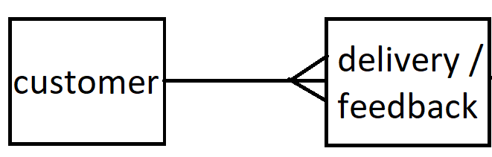

# Customer

Registration and login page for customer.

# Delivery / feedback

We make one of these per customer / per week on a standing order.

# Implementation

This program is best written with a database as there is strong coupling of information.

If a simpler design is desired, please feel free to adapt.

Any amount of complexity can be built on top of this for example by:

* Extending the database to include more information
* Writing responsive CSS for different devices
* Sending messages to people making them aware of status updates (e.g. new appointment)

# Additional things to think about

Passwords for admins

Sessions (security restrictions)

Error handling

User interface / Experience

Testing

Documentation (User guide / walkthrough && readme)

Responsive CSS

# Technologies needed

Angular

C# (Visual Studio web app project)

SQL

# Extended version:

https://codeshoppy.com/shop/product/agri-shop-for-farmers/

# Alternatives

Any kind of online shop here can act as an alternative.